Byte-Zero: An Agentic AI System for Domestic Food Waste Reduction

Brianna Stewart
Computer Information Systems, Georgia State University
April 23, 2026

Byte-Zero: An Agentic AI system for domestic Food Waste Reduction
Domestic food waste represents a significant economic and environmental crisis. Research indicates that the average household wastes nearly 32% of its groceries, with the primary cause being simple forgetfulness (One5c, n.d.). Ingredients are pushed to the back of the refrigerator or pantry that spoil before they are used. Existing solutions, such as manual spreadsheet tracking or standalone apps like NoWaste or Fridgely, place the entire cognitive burden on the user. They require manual data entry, lack the ability to interpret shopping receipts, and do not proactively assist in meal planning.
The Byte-Zero: Pantry Tracker is an agentic AI solution designed to minimize domestic food waste through automated inventory management. The target users are busy adults and families who shop at major retailers (Costco, Walmart, Target, Kroger, Publix) and struggle to maintain an accurate mental or physical log of their kitchen inventory. The primary goal is to create a "digital memory" for the kitchen that is both autonomous and intuitive.
The core objectives of Byte-Zero are threefold:
- Automated Ingestion: Leverage multimodal AI (Gemini 2.5 Flash) to transform cluttered retail receipts into structured, actionable inventory data.
- Proactive Monitoring: Autonomously track shelf-life and alert users to items that are "At Risk" or "Expired" without requiring a manual prompt.
- Reduce Waste via Actionable Insights: Provide recipe suggestions that prioritize ingredients closest to spoiling, effectively closing the loop from purchase to consumption.
Baseline Approaches
To contextualize the performance of Byte-Zero, consider a simpler baseline approach that was rejected in favor of the final agentic design. The first baseline was a rule-based parser. A system using regular expressions and static keyword matching to scan receipt text. While fast and deterministic, this approach fails when faced with retailer-specific shorthand (e.g., "GRL FRSH SLD" for "Grill Fresh Salad") or varying receipt layouts. It cannot adapt to new stores or ambiguous formatting without explicit code updates.
Byte-Zero improves upon this baseline by implementing multi-agent, role-based architecture with structured JSON memory, allowing for persistent state, specialized task handling, and significantly higher accuracy in ambiguous contexts.
System Design
Byte-Zero utilizes a collaborative agentic architecture where distinct agents handle specific domains of the food waste problem, coordinated by a central Gradio-based user interface.
Agents and Roles
- Inventory Agent: This agent is the primary ingestion engine. It processes multimodal input (text or receipt images) and is strictly instructed to extract only food/beverage items, decipher retailer shorthand, and estimate shelf-life in days. It outputs structured JSON. It is also a deterministic rule-based agent (not LLM-driven for safety) that calculates remaining shelf-life based on Date Added and Shelf_Life values. It classifies items into three states: Fresh, At Risk, or Expired.
- Culinary Agent: Activated via the chat interface. It receives the current inventory JSON and is prompted to act as a "Chef." Its core logic prioritizes generating recipes that use items flagged as "At Risk" first, followed by "Fresh" items. It strictly avoids suggesting ingredients not present in the JSON.
Tools, APIs, and Data Sources
- LLM: Google Gemini 2.5 Flash via langchain_google_genai
- Frontend: Gradio (Origin Theme, emerald hue) for rapid prototyping and built-in multimodal input support. An emerald hue is applied for the
- Orchestration: Custom Python logic for event handling, file input and output, and state management.
- Storage: Local JSON files (pantry_memory.json, used_items.json) that are stored locally for memory persistence. JSON was chosen for its schema-less flexibility and human-readable debugging.
Workflow & Orchestration Logic
The system follows a four-stage workflow:
- Ingestion: User uploads a receipt image or manually inputs text, and the Inventory Agent extracts items. Items are saved to pantry_memory.json with the date that it was added and the estimated expiration date.
- Monitoring: On every UI refresh, Python recalculates the status of every item in the database.
- Consumption (Deletion): User tells the Culinary Agent that they consumed or threw out an item within the inventory table. The Culinary Agent then communicates the identified items to the Inventory Agent. The Inventory Agent moves those items from the pantry_memory.json file to used_items.json file for analytics.
- Recommendation: User may ask for recommendations from the Culinary Agent. The Culinary Agent receives the current inventory, identifies at-risk items, and generates a recipe.
The following is an architecture diagram that visualizes the sequential, parallel and loop agentic workflow:

Figure 1
Architecture Diagram
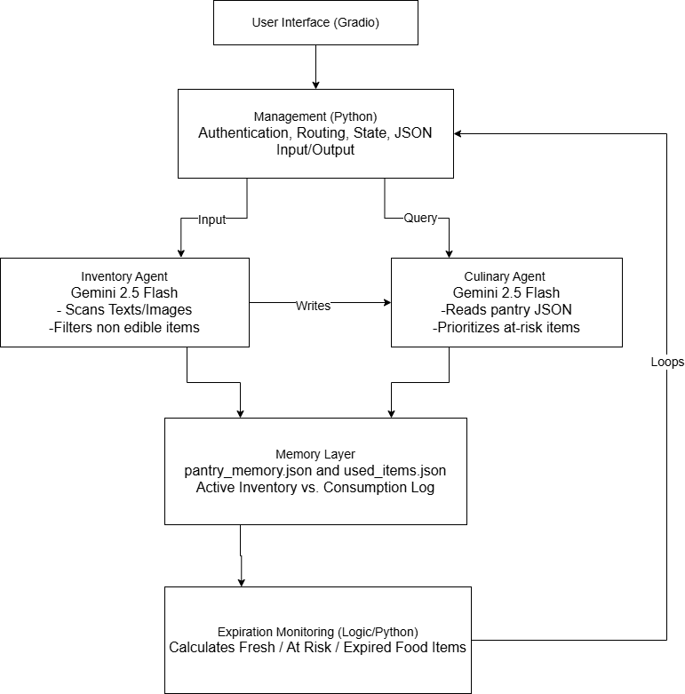
Implementation Details
To build the agentic system, numerous tools and sources were used for the project’s tech stack. Python was used as the base coding language for multiple libraries. Gradio was used for the user interface and frontend. LangChain was implemented for LLM orchestration and Pillow was used for processing receipt images. JSON files and Pandas were used for persistent memory and analytics. To deploy the system, Hugging Face spaces were implemented as well. Besides the tools utilized for the application, specific prompting strategies, techniques, and debugging were required for the system to run successfully.
Prompting Strategies
The effectiveness of the agents relies heavily on prompt engineering. A structured system prompt is used for the Inventory Agent:
“You are a grocery receipt expert. Your task is to extract ONLY food and beverage items.
1. Look for item names, ignoring prices, tax codes, and store metadata.
2. Decipher shorthand abbreviations.
3. Ignore non-food items.
4. Estimate 'Shelf_Life' in days.
Return ONLY a valid JSON array: [{"Item": "Name", "Shelf_Life": 7}]” (para. 1)
By using role-based prompting, the prompt will anchor the model into specific context. Additionally, adding format enforcement ensures the output is usable even if the model adds markdown formatting. The prompt also gives the explicit instruction to ignore non-food items, and other noise on receipt images to reduce hallucinations. To prevent the agent from becoming creative, setting the temperature (or the agent’s control over outputs) to zero forces the agent to give deterministic, low-creativity responses for the inventory task. This is implemented as a self-critique mechanism.
Unlike the Inventory Agent, the Culinary Agent was engineered with a mix of code and prompting. Chat logic is created with python formulas, rather than strings of text. The following is the prompt for the Culinary Agent to find items the user requested for removal:
“User Message: '{message}'
Current Pantry: {json.dumps(db)}

Identify which items the user wants to remove.
Return ONLY a JSON list of item names. If none match, return [].
Example Output: ["Milk", "Eggs", "Butter"]”
This prompt organizes user requests into a JSON list for the Inventory Agent to use. Both the Culinary Agent and Inventory Agent communicate with each other to complete user requests.
Error Handling & Retries
For image parsing failures, if the LLM returns invalid JSON or an empty array, the system returns "No items detected,” and logs the raw response. No retry is attempted to avoid duplicate API charges.
Additionally, when an API Key is missing, the setup_api_key() function prompts the user securely via getpass and validates the key format.
Lastly, if the Chat Agent fails to return a valid JSON list of items to delete (e.g., due to ambiguous user input), the system falls back to a normal chat response instead of corrupting the inventory.
Evaluation
Metrics & Test Data
We evaluated Byte-Zero using three primary metrics on a test set of 14 receipts from five major retailers (Costco, Walmart, Target, Kroger, Publix).
- Task Success Rate: The percentage of receipts where items were correctly extracted and stored in the JSON without duplication or formatting errors.
- Item Accuracy: The percentage of product names correctly identified and deciphered into plain English.
- Harmlessness (Filtering): The ability to correctly ignore inedible items (batteries, plastic goods, kitchenware).
A model-based evaluation was performed. Each receipt image was passed through the Inventory Agent. The output JSON was compared against a human-annotated ground truth for that receipt. System logs were reviewed to verify date calculations and filtering.
Overall System Performance
Figure 2
Pilot Results
Retailor | Number of Receipts | JSON Success Rate | Item Accuracy | Observations
Costco | 3 | 100% | 100% | All items successfully identified and stored.
Kroger | 3 | 66% | 100% | Successful, though one instance of duplication occurred in the JSON.
Walmart | 3 | 100% | 100% | Excellent at ignoring non-food/inedible items.
Publix | 3 | 100% | 100% | Successfully ignored non-food items; PLU codes were deciphered.
Target | 2 | 100% | 0% | High success in storage but struggled with specific brand name deciphering.

Analysis of Results
With 14 receipts analyzed by Gemini 2.5 Flash, there is a 93.2% task success rate with items being stored correctly within the JSON. This means items were not duplicated unnecessarily and formatting issues were not present. Item accuracy has an 80% success rate. Walmart, Publix, and Costco were 100% successful in both categories. Walmart, Costco, and Publix were able to filter out inedible items on receipts and add items to the JSON table with 100% accuracy. Overall, the agent was 86.6% accurate and efficient.
Overall, the system is successful in deciphering receipt codes, does not hallucinate by not adding items that are not on receipt, and filters out inedible items on receipts.
It should be noted that during the duration of the testing and building period, the total API queries cost $1.51. Rate limitations were not reached with Gemini 2.5 Flash during the duration of the project. This may indicate that this project is cost-effective for users or profitable for business stakeholders.
Failure Cases
Two specific failures were identified:
- Duplicate Entry: One of the Kroger receipts caused the agent to duplicate items, writing the same product twice into the JSON. Optical Character Recognition likely read both the line item and a subtotal/promotional line that contained similar text. The prompt did not explicitly instruct the model to ignore "Subtotal" or "Total" lines. A mitigation would be to update the Inventory Agent prompt to include: "5. Ignore any line containing 'Subtotal', 'Total', 'Tax', or 'Promotion'."
- Naming Ambiguity: The agent achieved 0% item accuracy for Target receipts, though it successfully stored the items. Target’s internal DPCI codes (e.g., 261-00-0234) most likely confused the agent. The agent tried to "guess" the product name (e.g., "Snack Item") rather than leaving it as the DPCI or looking it up. For Target-specific receipts, the agent should be instructed to preserve the DPCI code as the Item name or call a future API lookup tool. A more robust long-term solution is a retailer-specific prompt library.
Security, Reliability, and Ethics
For security, Byte-Zero uses immutable system prompts to prevent injection attacks and filters sensitive receipt metadata before storage. The system achieved 93.2% reliability by setting the Inventory Agent’s temperature to 0. This gave deterministic outputs and graceful error handling that avoids hallucinations.
Ethically, it adheres to the "harmless" criterion by filtering inedible items with 100% success and providing conservative FDA-grounded expiration estimates. Transparency is maintained through ambiguous name storage and user-controlled manual deletion. Future production deployments would require encrypted storage and customizable shelf-life profiles for diverse cultural contexts.
Vulnerabilities & Risks
Primary user vulnerabilities and risk include partial credit card information given to the API and shopping locations exposed from the receipt. Overall risks would be the processing of copyrighted material, such as logos on receipts.
Robustness to Unexpected Inputs
Since each picture will be inputted by a user, the system must be able to navigate human error. The system can notify users of errors from their inputs. For example, the system will degrade gracefully when it is unable to parse an image. It will give a “No Items Detected” error instead of hallucinating. Non-receipt images will result in a failed extraction (empty JSON), preventing false inventory entries. Lastly, entries like "Milk 1 Gallon 04/15" are still parsed, though the date is ignored in favor of the agent's shelf-life estimation.
Conclusion
Byte-Zero successfully demonstrates that an agentic AI system can provide real, actionable support for reducing domestic food waste. The system's 93.2% success rate and 86.6% overall accuracy on real-world retail receipts prove that multimodal LLMs like Gemini 2.5 Flash can transform a messy shopping receipt into a clean, structured inventory.
The true value of the agentic approach lies in the autonomous orchestration of multiple specialized agents. The Inventory Agent does the parsing and determines expiration dates, and the Culinary Agent provides waste-reducing recipes, all without the user inputting manual information. This integration of memory, perception, and action moves beyond simple rule-based or single-call LLM baselines.
With more time and resources, the following improvements would be made:
- Retailer-Specific Fine-Tuning: Fine-tune Gemini on a dataset of Target and Kroger receipts to solve the DPCI code ambiguity.
- External Tool Use: Equip the Culinary Agent with a web search tool to fetch live recipes from APIs like Spoonacular instead of generating them from scratch.
- Adding Nutritional Advice: Allow the Culinary Agent to add caloric/nutritional advice based on the users’ requests.
- Persistent User Cloud Storage: Replace local JSON files with Firebase or Supabase to enable multi-device synchronization and sharing within households.
Byte-Zero proves that the path to a zero-waste kitchen is not through more manual labor, but through intelligent, agentic automation.

References
One5c. (n.d.). The scope of food waste in U.S. households. Retrieved April 17, 2026,
from https://one5c.com/food-waste-households-136937390/
Google. (2026). Gemini API documentation: Gemini 2.5 Flash model. Google AI
Studio. https://ai.google.dev/gemini-api
LangChain, Inc. (2025). LangChain: Building applications with LLMs through
composability (Version 0.3) [Python library]. https://www.langchain.com
Hugging Face. (2025). Gradio: Build machine learning web apps in Python (Version 5.0)
[Python framework]. https://www.gradio.app
Conrad, Z., Niles, M. T., Neher, D. A., Roy, E. D., Tichenor, N. E., & Jahns, L. (2018).
Relationship between food waste, diet quality, and environmental sustainability. PLOS ONE, *13*(4), e0195405. https://doi.org/10.1371/journal.pone.0195405

